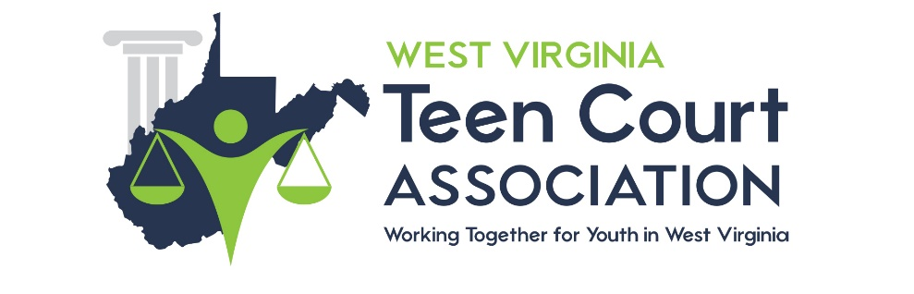
VOLUNTEER RECRUITMENT

Some Helpful Tips for Recruiting & Retaining Volunteers***

- Never let a day pass by without being involved in 1 youth court marketing activity
- Set specific program goals every year for recruitment and retention
- Maintain a tickler file for later use
- Always carry business cards with you. If someone asks for 1, give 2. They may know someone else who is interested
- Create a personal name tag or pin with your youth court name and logo on it and wear it to meetings
- Get a marketing intern, good way to help promote your program. They will get college credit and experience too!
- Take a tour of another youth court program, see what they are doing. Are there any new ideas that you have not considered?
- Publish a newsletter for stakeholders, community leaders
- Tweak your literature for different target markets
For example, sending literature to school administrators you really want to emphasize the service learning and law-related education aspects.
- Create a signature file on your e-mail to be used for all your e-mail messages, list your website, also list the NYCC website
- Use colored or oversized envelopes for direct mailing, increases curiosity. How many of us get several white envelopes in the mail each day?
- Always sign letters that have black font, in blue ink. Your name and organization will stand out and people are more likely to respond
- Keep a current media list so that press releases are sent to the right media outlet.
- Contact your local newspaper; send them info about your youth court-they are always looking for a story.
- Create an Annual Award and publicize it
- Possibly at end of year banquet and recognize the recipient

General Customer Service

- Return phone calls within 24 hours, if possible.
- Record a memorable outgoing message, include hours of youth court operation, time of trials, maybe a tip of the day.
- Send hand-written thank you notes
- Hold an open house
- Get a booth at the community fair or trade show
- Give a speech/volunteer for career day
- Keep former volunteers on your mailing list. You just might “reactivate them”

***This list was adapted from 100 Marketing Tips from the United States Small Business Administration, available at http://www.sba.gov as of 04-02-05.
Volunteer Job Description

Purpose of form: To inform volunteers of the expectations and duties of various volunteer roles.

Reason for form: Chapter 7, guideline 1 of the National Youth Court Guidelines state that job descriptions should be developed for all volunteer roles. The job description should outline the major responsibilities and tasks for the position so volunteers will know what is expected of them. Providing volunteers with clear and written expectations assists staff in managing the work of volunteers and can also decrease the likelihood of volunteer misconduct.

Suggested ways to use the form:
- Review sample format and determine if any modifications need to be made to the form to meet program needs.
- Complete all sections of the form for each volunteer job role – adult and youth volunteer positions.
- For active youth courts, get input from current volunteers on what should be included in the volunteer job description. Those who are currently performing the roles are in the best positions to help staff define the duties and responsibilities in writing.
- Provide a copy of the volunteer job descriptions to all volunteers. They will benefit from having a copy of their description, but may also find it interesting to know the duties and responsibilities of other positions – especially if they are interested in changing or being cross-trained in other roles.
- Place a date of revision on the job description and review and update on a yearly basis.

[Insert Program Name]
[Insert Program Contact Information]

Volunteer Job Description

Volunteer Title:

Duties/Responsibilities:

Expected Outcomes for Volunteers:

Qualifications:

Training:

Responsible to:

Time required:

Length of time commitment:

Revised [insert date]
Sample Volunteer Job Description

Volunteer Title:
Youth Volunteer Prosecuting Attorney

Duties/Responsibilities:
- Review facts of assigned cases with the Youth Court Coordinator.
- Discussing the respondent’s case with the youth defense attorney.
- Ensure that victims have been notified of the hearing and have been given the opportunity to provide impact information.
- Review victim impact information
- Interview and prepare victims/witnesses for the community
- Prepare opening and closing statements
- Prepare direct and cross examination.
- Make recommendation regarding the most fair, constructive, and restorative sentence for respondent based on information provided by the respondent, respondent’s family, victims, and community

Expected Outcomes:
- Enhanced public speaking skills.
- Better critical thinking and listening skills.
- Valued service to the community.

Qualifications:
Applicant must be enrolled as a full-time student in a secondary school in the county school district.

Training:
Applicant must complete the pre-service volunteer training program and participate in at least two mock youth court hearings.

Responsible to:
Teen court coordinator or designated adult volunteer

Time required:
Approximately 10 hours of pre-service training, with occasional requirements for in-service training.

Hearings are held on the second and third Tuesday evening of each month. Attorneys must arrive at 5:30 p.m. and stay until last assigned case is heard.

Attorneys also should commit to approximately 1-2 hours of preparation time for each case to be conducted at their convenience.

Length of time commitment: Program runs year round. Volunteers unable to commit to being available year round due to scheduling conflicts should inform youth court coordinator of personal availability.

Revised 04/04

